**User Manual**



**Total Cost of Ownership**

User Manual for the TCO-Tool

**Version 1.5.1**

**Document Info**

Filename: *TCO-Tool User-Manual.docx*

Responsible: *Peter Hirzel (info@softenvironment.ch)*

Classification: public

**Change History**

|  |  |  |  |  |  |
| --- | --- | --- | --- | --- | --- |
| **Date** | **Version** | **Status** | **Company** | **Author** | **Remarks** |
| 2005-11-26 | 1.4.0 | In Development | *soft*Environment | Peter Hirzel | Initial |
| 2006-05-07 | 1.4.1 | In Development | *soft*Environment | Peter Hirzel | Chapter „User Interface“ enhanced |
| 2007-06-19 | 1.4.4 | Release | *soft*Environment | Peter Hirzel | Adaption to V1.4.4 |
| 2008-06-21 | 1.4.5 | Release | *soft*Environment | Peter Hirzel | Adaption to V1.4.5 |
| 2012-11-10 | 1.5.0 | Release | *soft*Environment GmbH | Peter Hirzel | Adaption to V1.5.0 |
| 2013-09-24 | 1.5.1 | Release | *soft*Environment GmbH | Peter Hirzel | More details about Catalogue-Part, Role |

Contents

1. Prolog 7

1.1 Initial Project 7

1.2 Donation 7

2. About the document 9

2.1 Further reading 9

2.2 License 9

2.3 Technology 9

3. Concepts of the TCO Method 10

3.1 History 10

3.2 TCO is not classic accounting! 10

3.3 Goals of the TCO-Tool 11

3.3.1 Why the TCO-Tool instead of an Excel-Sheet? 11

3.3.2 Black box vice white box tools 12

4. Design of the TCO-Tool 13

4.1 Base Information 13

4.2 Control 14

4.3 Cost-Model 14

4.4 TCO/Generic Reports 14

5. User Interface 15

5.1 Launcher 15

5.1.1 Menu 15

5.1.2 Toolbar 17

5.1.3 Navigation-Tree 17

5.1.4 Note-Area 17

5.1.5 Output-Area for Reports 17

5.1.6 Statusbar 17

5.2 Managing Base-Information 18

5.2.1 Configuration 19

5.2.2 Group 20

5.2.3 Service 21

5.2.4 Cost driver 23

5.2.5 Fact cost 26

5.2.6 Personal cost 28

5.3 Control 29

5.3.1 Business Objects / Codes 29

5.3.2 Options 35

5.3.3 Currencies 37

5.3.4 Find Objects 37

6. Calculation basics 39

6.1 Cost model algorithms 39

6.1.1 TCO Algorithm 39

6.1.2 Financial Algorithm 39

6.2 Multiplicity 40

6.3 Time duration 40

6.4 Base offset 41

6.5 Dependency 42

6.6 Risk-Calculation 42

6.7 Cost block 42

7. Generic Reports 43

7.1 Configuration Reports 43

7.1.1 Report (complete) 43

7.1.2 Dependency-Graph 44

7.2 TCO-Reports 45

7.2.1 Cost block (overall) 45

7.2.2 Cost block (detailed) 46

7.2.3 Personal-/Fact costs (over all) 47

7.2.4 Business objects (Codes) 47

7.2.5 Subordinate Business objects (codes) 49

7.2.6 Direct/*indirect* costs 49

7.2.7 Dependency costs 50

7.2.8 Estimated costs 51

7.2.9 Price suggestion 52

7.3 Accounting/Financial Reports 53

7.3.1 Personal costs 53

7.3.2 Check personal effort 55

7.3.3 Investments 55

7.3.4 Budget plan 56

7.3.5 Depreciation 57

8. FAQ 59

9. Appendix 60

9.1 TCO „Base Information“ Model-Elements 60

9.2 Chart of Accounting [Gartner Group] 60

9.3 Import Business Codes 61

9.3.1 Import “Cost-centre” 61

9.3.2 Import “Cost-type” 61

Figures

Figure 1 – Core components of the TCO-Tool 13

Figure 2 – Sample TCO tree 14

Figure 3 – Launcher areas 15

Figure 4 – Toolbar 17

Figure 5 – Statusbar 17

Figure 6- TCO-elements in navigation tree 18

Figure 7 – Common attributes of a TCO-element 19

Figure 8 – Detail: configuration 20

Figure 9 – Detail: Group 20

Figure 10 – Detail: Service 21

Figure 11 – Detail: Service (panel Dependencies) 22

Figure 12 – Detail: Service dependency 23

Figure 13 – Detail: Cost driver 24

Figure 14 – Detail: Cost driver (panel site-Assignment) 25

Figure 15 – Detail: Site occurrence 26

Figure 16- Detail: Fact cost 27

Figure 17 - Detail: Personal cost 28

Figure 18 - Code administration 30

Figure 19 - Simple code 30

Figure 20 - Detail: Cost centre (complex code) 31

Figure 21 - Detail: Site (complex code) 32

Figure 22 – Detail: Cost-type (complex code) 33

Figure 23 - Detail: Role (complex code) 34

Figure 24 – Detail: Catalogue-Part (complex code) 35

Figure 25 – Options 36

Figure 26 - Detail: Currencies 37

Figure 27 – Search dialog 38

Figure 28 – Linear depreciation of an asset over years 40

Figure 28 – Duration for TCO or Financial aspects 41

Figure 28 - Base offset illustration 41

Figure 29 - Report (Complete) 44

Figure 30 - Dependency Graph 45

Figure 31 - Report: TCO-cost block (over all) 46

Figure 32 - Report: TCO Personal-/Fact cost (over all) 47

Figure 33 - Sample pie chart 48

Figure 34 - Sample bar chart 48

Figure 35 - <Cost type> by a Frontend and Backend <Category> 49

Figure 36 - Direct/indirect costs report 50

Figure 37 - Estimated/well known costs report 52

Figure 38 – Price of a „single“ service instance 53

Figure 39 - Report: Personal costs 54

Figure 40 – Personal effort vice availability 55

Figure 41 - Report: Investment 56

Figure 42 – Budget plan 57

Figure 43 - Report depreciation 58

Figure 44 – TCO-Tool Class Model 60

Figure 45 – TCO Model v4.0 – Distributed computing Chart of Accounts 61

# Prolog

## Initial Project

The TCO-Tool results from an Open-Source Project by the [Swiss Federal Steering Unit FITSU](http://www.isb.admin.ch/index.html?lang=en) to initially calculate the workplace costs of a government PC.

**[](http://www.isb.admin.ch/index.html)**

Conception:

[](http://www.phw.info/)

Conception, architecture & development:



## Donation

Please donate for the future development of the TCO-Tool at

 <https://sourceforge.net/projects/tcotool>

If you think the TCO-Tool is useful for your calculations and you want more functionality in shorter release cycles, your donation will be most appreciated. Your donation will be used 100% for extending the functionality and standardization of calculations to be done by the TCO-Tool. If you have a specific feature in mind you want to invest for, please contact the project-administrator directly to do so

**The Project is maintained and developed continuously by** <http://www.softenvironment.ch>:



Thank you very much.

# About the document

This document describes the concepts and user-interface of the TCO-Tool.

## Further reading

* <http://www.tcotool.org> (the project site)
* <http://sourceforge.net/projects/tcotool/> (the source archive)

Besides there is lots of reading about TCO, RCO, etc…

## License

All source code distributed with the TCO-Tool is based on open-source license models.

**[](http://www.softenvironment.ch/portrait/introducing.html%23%23)**

LGPL <http://www.gnu.org/copyleft/lesser.html>

## Technology

Developed in Operating System independent technology:



Supported version: [Java SE](http://www.oracle.com/technetwork/java/javase/downloads/index.html) (Version 6 or later)

# Concepts of the TCO Method

Within this document TCO[1] is understood as follows:

* *Definition*: **Total cost of ownership (TCO)** is a financial estimate whose purpose is to help consumers and enterprise managers **determine direct and indirect costs of a product or system**. It is a [management “accounting](http://en.wikipedia.org/wiki/Management_accounting)” concept that can be used in [full cost accounting](http://en.wikipedia.org/wiki/Full_cost_accounting) or even [ecological economics](http://en.wikipedia.org/wiki/Ecological_economics) where it includes [social costs](http://en.wikipedia.org/wiki/Social_costs).
* The related concepts were developed by Gartner.

Important:

* Do not misunderstand the TCO-Certification program for ICT products within this document (for e.g. <http://www.ecolabelindex.com/ecolabel/tco-development>) which is a label to express something totally else.

## History

In the past a few consulting companies like Gartner, Metagroup, Gigagroup and others introduced methods (such as TCO, RCO, TEI) to calculate the costs for specific Information Technology (IT) environments.

They were focused mainly on the matter of a workplace, by means “what does it cost to run and maintain a Personal Computer (PC) for an employee?” In fact, this question is easily underestimated and needs proper analysis about:

* Hardware
* Software
* Education
* Roll-out
* Maintenance
* etc

Some **costs** are rather **direct** and simple to guess others are more **indirect** and not obvious at first sight (for e.g. downtime of a related Server).

## TCO is not classic accounting!

Often people think they know the costs from their accounting manager or they could assume TCO out of it easily. This understanding is fatal and usually wrong. TCO is not a synonym for accountancy, but TCO might even deal with the same facts though in a different approach.

If you want to buy/sell a product for a better price on the market you need to know the exact costs related to it. Therefore TCO could be a good method to find out, whether some innovation for a product might lead to a good ROI (return of invest) later.

TCO summarizes the costs over a **lifecycle of a product or service** where accounting controls the bookings about investments per year usually. Also the **usage tim**e of the product is usually not the same like the **depreciation time**! Further in an accounting system any salaries of personal resources should be well known, but does it know as well how many hours an employee works for your concrete configuration which is only a part of your enterprise?

## Goals of the TCO-Tool

TCO is a method to determine the “real production/operating costs” of a product or service or their many variations.

Anything related to costs can be of interest, therefore TCO is not bound to IT or ICT branch only, the concepts can be used to calculate other business areas as well (for e.g. medical treatment in a hospital for special diseases, building elements of a house, car lifetime comparisons etc).

The TCO-Tool will help you to model relations between coupled objects in the whole usage time and costs and even deals with **repeatable investments**. It clearly **separates between facts and personal effort** over the whole usage time.

Further the TCO-Tool comes with many pre-defined and well structured elements throughout your modeling process, for e.g. concrete **cost-types** (for direct & indirect costs), a recursive **multitude** mechanism etc.

### Why the TCO-Tool instead of an Excel-Sheet?

Many TCO responsible’s calculate their TCO with an Excel-Sheet, which means:

* Every sheet looks probably different in structure (low **interchangeability**!)
* It is hard to model a variable **set** of elements (**complex infrastructure**!).
* Formulas are hand built, by means your figures are as good as your formulas (**interpretation of figures!**). Recursive calculations might need some script extensions…
* No built in TCO repository, that separates between personal and fact costs by foreseen structures.
* An Excel-Sheet is limited to 2 dimensional rows and columns, as soon as you run into a **tree like structure** of your products and services it gets complicated.

The **TCO-Tool** tries to eliminate these lacks given by Excel-Sheets andtries to **set a standard for TCO calculation…**

If you are used to flat spread-sheets, you might experience problems transforming facts into a tree structure with the correct dependencies amongst them at first. But you will learn quickly the advantages of a well structured though flexible tree vice wild open table-cells. The TCO-Tool will allow you to model similar kind of information in a strict way which is very important for comparison and evaluation by generic reports.

Finally the most powerful feature awaits you, if you start playing with your configuration by moving some tree elements to another node, this is when your spread-sheet colleagues run into chaos normally… Still you can count on well defined calculation algorithms to calculate the TCO costs of the whole tree or just some branches of it.

### Black box vice white box tools

The past brought up some inaccurate black box tools, where you could enter some common parameters (such as “branch”, “average income”, “number of employees”) and in the end some wizardous oracle compared those figures against a non-transparent repository to tell you what your TCO is.

The inventors of this tool do not believe in such magic, therefore the TCO-Tool is a complete **white box tool**. Unfortunately this means you have to enter any facts you know about your products or services. However this effort is worth it, when you start playing with the given facts sooner or later.

# Design of the TCO-Tool

Your **real world business case** is what you want to shape in a data model and gain more cost transparency by the TCO-Tool about it. It represents your work, environment, infrastructure, products, services and staff.

Usually it takes some effort to dig out all related and important details of your business case to estimate. At this point the TCO-Tool gets on stage to help you make a good guess what the real TCO is and allows you to represent figures even graphically.

The TCO-Tool consists of 4 different aspects or components:

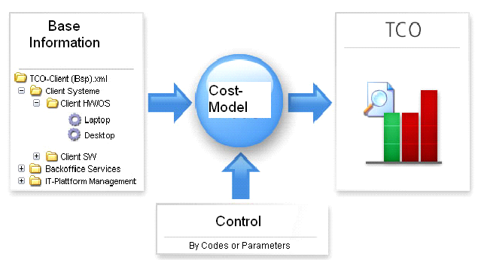

Figure 1 – Core components of the TCO-Tool

## Base Information

Contains the business data details of your system (for e.g. an ICT-infrastructure[2]) within its lifecycle being calculated by the *Cost-Model*. A generic tree-structure allows adding concrete data model-elements, such as *Groups*, *Services*, *Cost-driver* and *Fact*- and *Personal costs*. Costs may be distributed among *Groups* and *Services*.

The *Base Information* is represented as a flexible tree structure of your input data. It is based on TCO-Tool specific model-elements (see chapter 5.2) and are presented as nodes in the navigation-tree. Such a tree of might look like that:

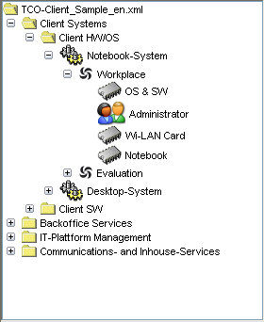

Figure 2 – Sample TCO tree

(See also 9.1 for technical Details.)

## Control

Various customizable *business-objects (codes and enumerations)* and system-parameters will be used to classify and extend *Base Information* and to drive the calculation of costs.

## Cost-Model

The core of the TCO-Tool is a *Cost-Model*. This aspect implements the TCO algorithm and defines therefore how costs are calculated mathematically. Two inputs do influence results: (1) *Base-Information* and (2) *Control*.

## TCO/Generic Reports

The output of the calculated *Cost-Model* can be generated and expressed by various reports in textual and graphical ways. These are mainly HTML-Reports or useful graphical diagrams. Some of these HTML-Reports can be exported as CSV[3] to be further used by Excel.

# User Interface

The TCO-Tool is realized as a standalone application. Since it is developed in pure Java it will look always more or less the same whether it is running on Windows, Linux, Mac OS X or whatever other operating system with a Java Runtime Environment (JRE).

## Launcher

The Launcher is the main window showing up after program start.

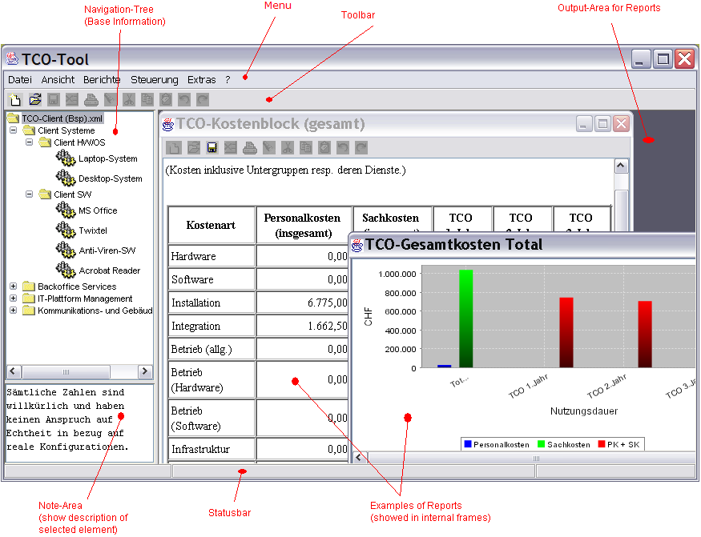

Figure 3 – Launcher areas

### Menu

Some standard and some specific application menu-items are to be shown:

File

|  |  |  |
| --- | --- | --- |
| **Menu-Item** | **Mnemonic** | **Description** |
| New |  | Create a new Configuration with a default tree. |
| Open… |  | Open an existing Configuration (XML-file). |
| Open recently |  |  |
| Import… |  | Import different *Business Code*’s see chapter 0. |
| Save | Ctrl + S | Save the current configuration (to XML-file). |
| Save as… |  |  |
| End |  | Exits program |

Edit

|  |  |  |
| --- | --- | --- |
| **Menu-Item** | **Mnemonic** | **Description** |
| Find… |  | Opens a search-Dialog, s. chapter 5.3.4. |

View

|  |  |  |
| --- | --- | --- |
| **Menu-Item** | **Mnemonic** | **Description** |
| Look & Feel |  | Change display-manager (platform dependent) |
| Font |  | Choose between normal and big font. |

Reports

|  |  |  |
| --- | --- | --- |
| **Menu-Item** | **Mnemonic** | **Description** |
| * |  | s. chapter 6 |

Settings

|  |  |  |
| --- | --- | --- |
| **Menu-Item** | **Mnemonic** | **Description** |
| Business Objects (Codes)… |  | Define your specific Codes. |
| Options (Defaults) |  | Common settings. |
| Currencies… |  | If your costs are given in more than one currency you should define courses between them (necessary to compare costs). |

Extras

|  |  |  |
| --- | --- | --- |
| **Menu-Item** | **Mnemonic** | **Description** |
| Language |  | Change language of user interface (UI). |

Help

|  |  |  |
| --- | --- | --- |
| **Menu-Item** | **Mnemonic** | **Description** |
| Help |  | Show Help page. |
| Information… |  | Show About-dialog. |
| Platform Info… |  | Show Java and other host-info. |

### Toolbar

Contains a set of useful functions (some of them are also available in Menu).

$°

Figure 4 – Toolbar

### Navigation-Tree

The Navigation-tree contains all **Base-Information** (see chapter 5.2) resp. a *TCO-Configuration* with different Services within logical Groups (TCO-Package).

The following „Element-types“ exist in a tree:

* ** TCO-Configuration** => Root-Element
  + ** Group** 
    - ** Service**
      * ** Costdriver** 
        + ** Factcost**
        + ** Personalcost**

### Note-Area

Shows description of the selected element in Navigation-tree.

### Output-Area for Reports

Window for internal frames representing generic reports.

### Statusbar

Shows dynamic application feedback.



Figure 5 – Statusbar

|  |  |  |
| --- | --- | --- |
| **Area** | **Type** | **Description** |
| <left> |  | Current message. |
| <middle> |  | Events/state. |
| <right> |  | Time stamp of last change.  Future use |

## Managing Base-Information

All *Base information* in a TCO-Tool file is displayed in the Navigation-Tree.

Use **right popup-menu** to **display a content-sensitive menu** and appropriate dialogues for each Tree-element/node.

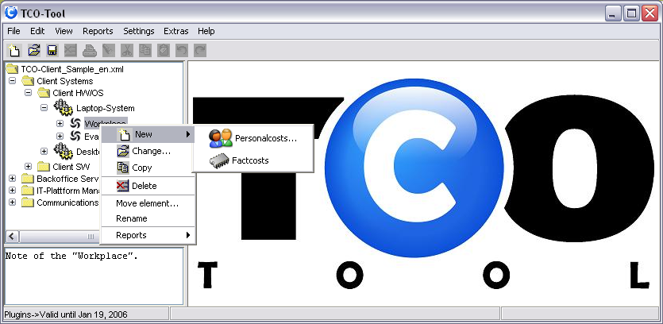

Figure 6- TCO-elements in navigation tree

Each Tree-node/element further on called “TCO-object” - has its own symbol and a context specific popup-menu:

|  |  |  |
| --- | --- | --- |
| **Menu-Item** | **Mnemonic** | **Description** |
| New |  | Create a new TCO-Object. According to the selected element the possible options are provided automatically by the TCO-Tool. (Therefore you do not need to worry to maintain the same structures all over a configuration.) |
| Change… |  | Open the appropriate dialog for the selected element. |
| Copy |  |  |
| Delete |  | Import different *Business Code*’s see chapter 0. |
| Move element… | Ctrl + S | Save the current configuration (to XML-file). |
| Rename | F2 |  |
| Reports |  | Show a list of available Reports for the selected element.  Important:   * Only the selected element will be considered in the report! |

Each TCO-object has some **common attributes**:

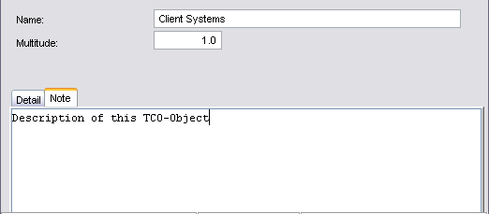

Figure 7 – Common attributes of a TCO-element

|  |  |  |
| --- | --- | --- |
| **Attribute** | **Type** | **Description** |
| Name | Text | Name of TCO-object. |
| Multitude | Text | Multiplier or number of this object existing in real world.  See also chapter 6 |
| Note | Text | Some further description on the element. |

### Configuration

Root-element[4] corresponding to an XML-instance to save *Base-Information* and *Control* objects persistently to a file (for e.g. MyConfiguration.xml).

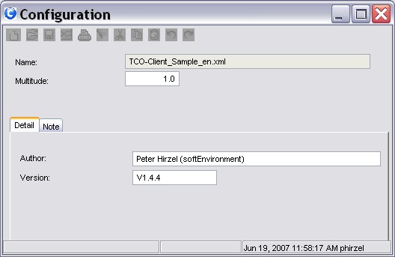

Figure 8 – Detail: configuration

|  |  |  |
| --- | --- | --- |
| **Attribute** | **Type** | **Description** |
| Author | Text | Author of a configuration. |
| Version | Text | Version of a configuration. |

### Group

Logical TCO-package to group *Services* in a generic manner. *Groups* may be used in recursive manner (by means hierarchical sub-groups).

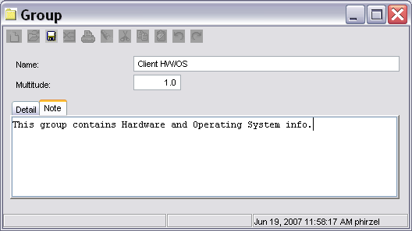

Figure 9 – Detail: Group

### Service

Atomic unit (“cost-carrier”) of interest to be calculated with TCO-facts and figures. This might be for e.g. a workplace computer. **Dependencies** may be defined between *Services* and *Groups* to distribute their costs among others.

Definition:

* A *Service* is what a service-provider offers to a client/customer to do a certain task. Though a customer thinks rather product oriented, a *Service* must not be a specific product itself, it can also be a set of services from the point of view of a service-provider.

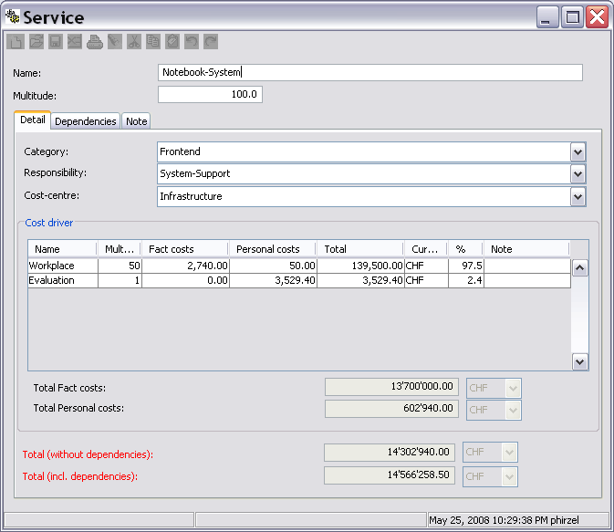

Figure 10 – Detail: Service

It is possible that a *Service* (client for e.g. specific client-software) depends on another *Service*, by means the costs of the supplier are shared among all clients.

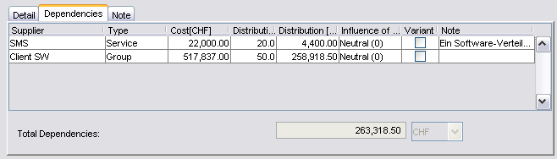

Figure 11 – Detail: Service (panel Dependencies)

|  |  |  |
| --- | --- | --- |
| **Attribute** | **Type** | **Description** |
| Category |  | Kind of *Service*. |
| Responsibility |  | Who is responsible (department, process, etc). |
| Cost-centre |  | Financial booking reference. |
| Cost driver |  | List of costs for a *Service* (see chapter 5.2.4) |
| Total Fact costs |  | Sum of *Fact costs* within all *Cost drivers*. |
| Total Personal costs |  | Sum of *Personal costs* within all *Cost drivers*. |
| Total (without dependencies) |  | *Service* costs alone. |
| Total (including dependencies) |  | *Service* costs alone plus shared costs of assigned suppliers. |

#### Dependency !°

Define a relation between a client-*Service* and a supplier-*Service or supplier-Group*. The costs of a supplier may be shared among other clients, where client-cost may become more expensive, based on the cost distribution from the supplier, s. 6.5).

*Dependencies* may be visualized by “Dependency Graph” (see chapter 7.1.2

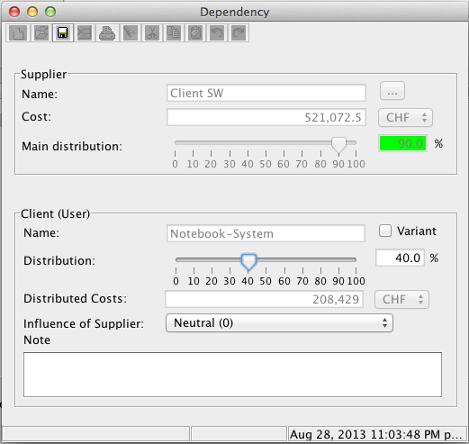

Figure 12 – Detail: Service dependency

|  |  |  |
| --- | --- | --- |
| **Attribute** | **Type** | **Description** |
| Name (supplier or client) |  | Service-Name |
| Cost (supplier) |  | Total cost of supplier |
| Main distribution |  | A supplier must not be shared among clients over 100%. However the Tool just reminds you by a color warning if you over distribute.  Remark:   * Turns green if distribution is acceptable (<=100%). * Turns to red if over-distributed (>100%). |
| Distribution (client) |  | Define the percentage of supplier-costs should be shared (distributed) to the client. |
| Distribution costs (client) |  | The costs of sharing for this client. |
| Variant (client) |  | TODO: Future use for comparison |
| Influence of supplier |  | TODO: future use |
| Note |  | Description of dependency |

### Cost driver

This term needs further definition. Literally a *Cost driver* might be understood as a thing to drive costs, like the multitude. Within the *TCO-Tool* its meaning is rather a sub-container in a *Service* to manage different *Fact costs* and *Personal costs*.

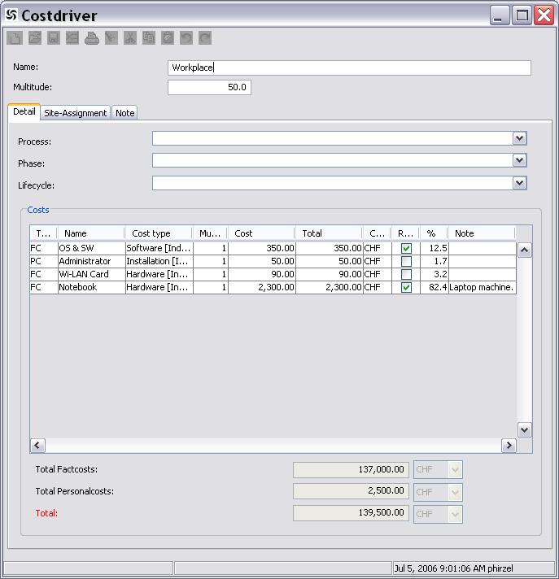

Figure 13 – Detail: Cost driver

A *Cost driver* may also be distributed among regional sites:

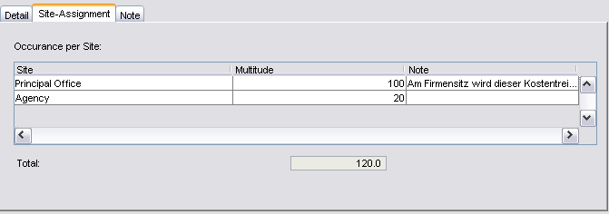

Figure 14 – Detail: Cost driver (panel site-Assignment)

|  |  |  |
| --- | --- | --- |
| **Attribute** | **Type** | **Description** |
| Process |  | A *Cost driver* may belong to a specific process. |
| Phase |  | A *Cost driver* might by relevant during a specific phase. |
| Lifecycle |  | A *Cost driver* may be relevant for a certain lifecycle. |
| Total *Fact costs* |  |  |
| Total *Personal costs* |  |  |
| Total |  |  |
| Site-assignment/occurrence per site |  | See chapter 5.2.4.1 |
| Total (site-assignments) |  | Regional parts at all to spread among all sites. |

#### Site occurrence

*Cost driver* costs may be spread among regional sites by site-assignments. TODO SITE FORMULA

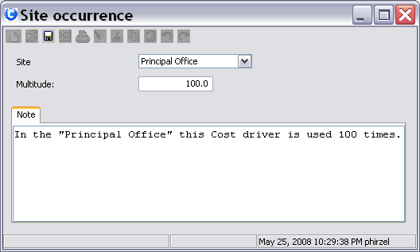

Figure 15 – Detail: Site occurrence

|  |  |  |
| --- | --- | --- |
| **Attribute** | **Type** | **Description** |
| Site |  | Occurrence/usage of *Cost driver* for a specific regional location.  See chapter 5.3.1.3 |
| Multitude |  | Factor of usage |

### Fact cost

Known costs corresponding to any hardware related objects in reality. *Fact costs[5]* have a TCO-usage time and a different depreciation time (as in accountancy). Repeatable means they have to be reinvested again after TCO-usage time is over.

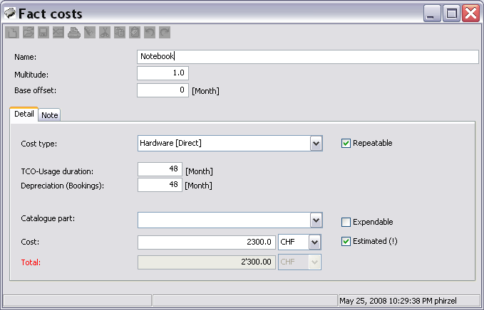

Figure 16- Detail: Fact cost

|  |  |  |
| --- | --- | --- |
| **Attribute** | **Type** | **Description** |
| Base Offset | Integer | Delay of cost impact after the beginning of any calculation in months (see chapter 6.3) |
| Cost type (cause) |  | Assign a specific *Cost type*, which results into the typical Gardner approach of **direct or indirect costs** (see chapter 5.3.1.5)**!** |
| TCO-usage duration |  | The planed usage of a “thing” by a user. |
| Repeatable | Boolean | If true TCO-usage and depreciation will be reconsidered after that time for a long time period. |
| Depreciation (accountancy/bookings) |  | “Financial accountancy time where a thing values nothing any more”. |
| Catalogue part |  | Choose a well defined thing out of a catalogue (fixed price and duration).  See chapter 5.3.1.7 |
| Expendable[6] | Boolean | Define whether a thing is to be used as tool (for e.g. Computer), consumale supplies or "throw away material" like paper in a printer. |
| Cost | Double | Price of a “thing”. |
| Estimated | Boolean | Whether the costs of a thing is well known or not. |
| Total |  | Cost twice (*) multitude. |

### Personal cost

Personal effort realized by human resources. These costs have no TCO-usage or depreciation time, they are rather valid for a whole year and might be repeatable in the following years.

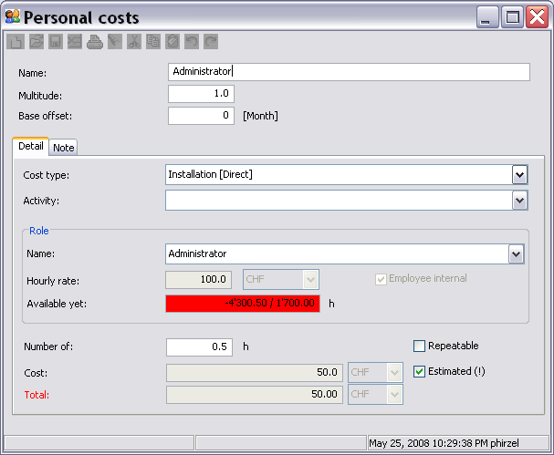

Figure 17 - Detail: Personal cost

|  |  |  |
| --- | --- | --- |
| **Attribute** | **Type** | **Description** |
| Base Offset | Integer | See explanation in 5.2.5 |
| Cost type |  | See chapter 5.2.5 |
| Activity |  | Category of personal activity or kind of effort. |
| [Role] Name |  | See chapter 5.3.1.5 |
| [Role] Hourly rate | Double | Cost per hour of that role. |
| [Role] Employee internal | Boolean | True: internal employee (hired by contract)  False: external employee (for e.g. temporary consultant or coach) |
| [Role] Available yet |  | This helps to know how many hours of a resource are still available within the same TCO-configuration.  Colors:   * Red: over-assignment * Green: still available |
| Number of |  | Hours to be worked for this personal effort. |
| Repeatable | Boolean | If true effort must be considered **every Year**.  Remark:   * Personal costs have no usage duration by definition in TCO-Tool! |
| Cost | Double | Calculated cost for an effort Unit. |
| Estimated | Boolean | Whether the costs for Personalcost is exactly known or not. |
| Total | Double | Total Personal effort 8 Costs twice multitude) |

## Control

Manage Codes and System-Parameters for your configuration.

### Business Objects / Codes

Reusable simple and complexe Codes are important for further evaluations, reporting and even comparing different configurations by assigning the same business objects to different TCO objects of the same type.

Codes are designed for specific TCO objects as shown below and can be maintained by:

* *Menu Settings->Business Objects (Codes)* in the Launcher.

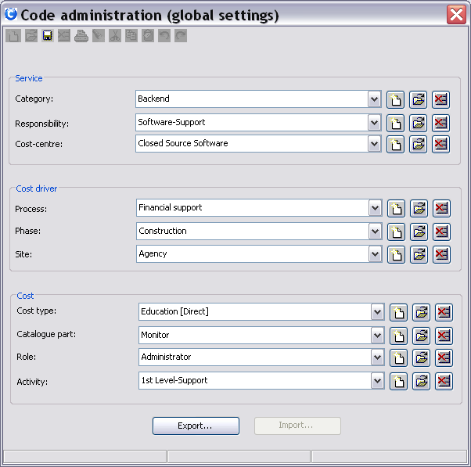

Figure 18 - Code administration

The above figure shows what code is related to what TCO-object within the base informations.

#### Simple codes

Simple codes have a name attribute only, for e.g:

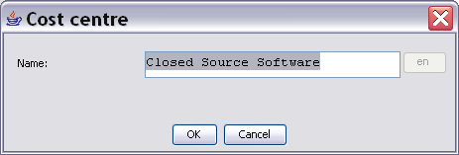

Figure 19 - Simple code

|  |  |  |
| --- | --- | --- |
| **Attribute** | **Type** | **Description** |
| Name |  | Name of simple code.  Future use:   * The “en” button right to the textfield shows a multi-language translation. |

#### Complex codes

Complex codes have next to the name attribute other specific properties and therefore its own dialog.

##### Cost centre

Cost centre can also be imported (see chapter 9.3.1)

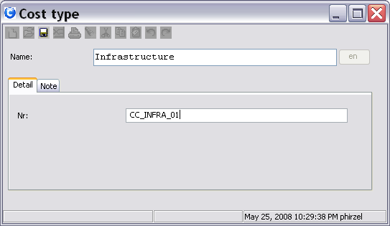

Figure 20 - Detail: Cost centre (complex code)

##### Site

To be assigned in *Cost driver* to calculate costs by site.

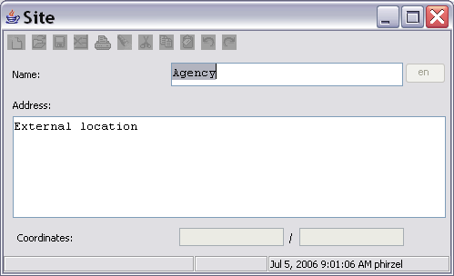

Figure 21 - Detail: Site (complex code)

|  |  |  |
| --- | --- | --- |
| **Attribute** | **Type** | **Description** |
| Name |  | Name of location. |
| Address |  | Physical address of building or room. |
| Coordinates |  | Geographic coordinates (latitude/longitude) |

##### Cost-type

According to Gartner „Cost-types“ are one of the **main concerns behind the TCO method**. To get further ideas what direct and indirect costs could be, please check 9.2.

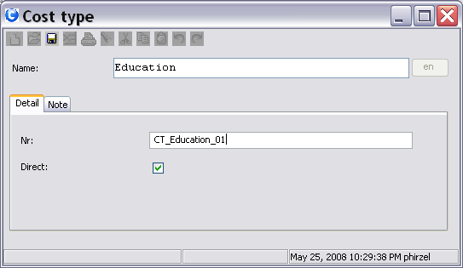

Figure – Detail: Cost-type (complex code)

|  |  |  |
| --- | --- | --- |
| **Attribute** | **Type** | **Description** |
| Nr |  | Unique identification for the code. (Also useful for importing codes from a *.csv)  TODO: In the future the name-attribute is an translatable field. |
| Direct | Boolean | According to Gartner cost are either direct or indirect for TCO-calculations. |

Remark:

* Cost-type can also be imported (see chapter 9.3.2)

##### Role

To be assigned in *Personal cost* as role of a personal effort (for e.g. administrator, supporter, hot-line, etc).

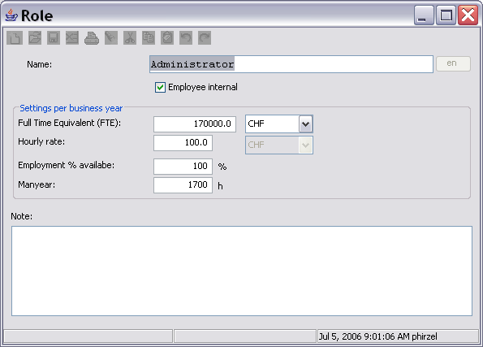

Figure 23 - Detail: Role (complex code)

|  |  |  |
| --- | --- | --- |
| **Attribute** | **Type** | **Description** |
| Name |  | Name of personal role. |
| Full Time Equivalent (FTE) |  | Salary for a resource of this kind. |
| Hourly rate |  | Payment per hour of effort done. |
| Employment % available |  | Say how many resources of this kind of role are available at all in your enterprise. |
| Man-year |  | How many working hours make up a man-year[7] for a resource of this role. |

##### Catalogue-Part

This special kind of Code is useful to define well known products (typically from a real world manufacturer) in a TCO configuration. Once defined, they may be reassigned to any **Fact cost**’**s** in the model as often as desired.

In this example a “Dell 19 inch Monitor” is defined as a Catalogue-Part or Product:

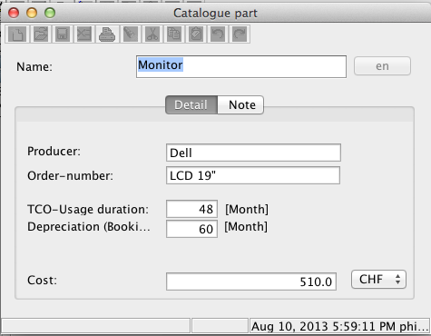

Figure 24 – Detail: Catalogue-Part (complex code)

|  |  |  |
| --- | --- | --- |
| **Attribute** | **Type** | **Description** |
| Producer | Text | Manufacturer |
| Order-number | Text | An article number known in your environment. |
| * <other> |  | S. 5.2.5  **Important:**   * If such a Catalogue-Part is really assigned to a Fact cost entry, these Attributes cannot be overwritten within the Fact cost entry any more * Changing these values in the Catalogue-Part changes all Fact cost entries within the same configuration. |

### Options

Define system-parameter settings for a configuration:

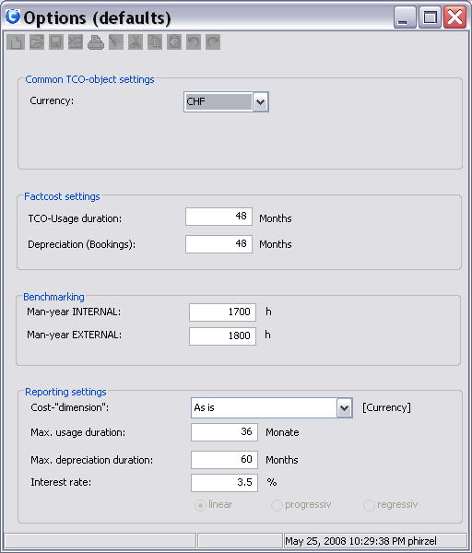

Figure 25 – Options

|  |  |  |
| --- | --- | --- |
| **Attribute** | **Type** | **Description** |
| Currency |  | Default currency to compare (intermediate currency).  See chapter 5.3.3 |
| TCO-usage duration |  | Default for new *Fact cost*-elements. |
| Depreciation (accounting/bookings) |  | Default for new *Fact cost*-elements. |
| Man-year INTERNAL |  | Default for new *Personal costs*. |
| Man-year EXTERNAL |  | Default for new *Personal costs* (such as Consultants). |
| Cost-„dimension“ |  | Formatting setting for amounts:   * 1’000’000 * 1’000 k * 1 Mio |
| Max. usage duration |  | Period to consider in reports generally. |
| Max. depreciation duration |  | Period to consider in reports generally. |
| Interest Rate |  | For financial calculations. |

### Currencies

Different currency converters are used to transform costs to ONE comparable goal currency, if costs are given in different currencies.

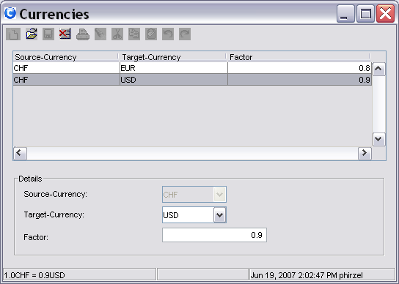

Figure 26 - Detail: Currencies

|  |  |  |
| --- | --- | --- |
| **Attribute** | **Type** | **Description** |
| Source currency |  | Always the same -> comparable currency. The source/reference currency can be defined in 5.3.2. |
| Target currency |  | Alternate additional currency. |
| Factor |  | Course |

### Find Objects

The Find-Dialog allows searching the TCO-tree.

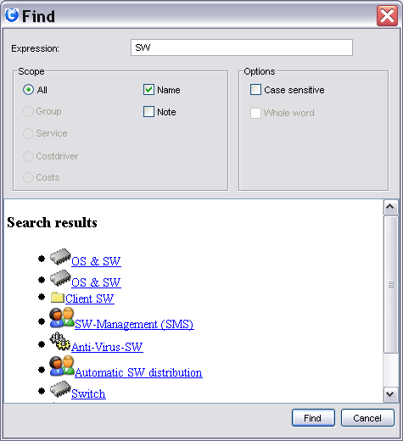

Figure 27 – Search dialog

Clicking a result-link will select the appropriate element in the navigation-tree.

# Calculation basics

## Cost model algorithms

There are two separate calculation approaches within the Tool, each based on summarizing algorithms. The Reports are titled either „**TCO \***“ or „**Financial \***“ iterating over the same configuration summarizing in a different way.

Costs are reprented by concrete:

* Fact costs
* Personal costs

All other elements (Groups, Services, Costdrivers) are only structures to add and distribute such cost elements.

### TCO Algorithm

The TCO-Tool has a somewhat own approach to summarize the given Base Information.

Investment- or Personal costa are divided over the whole TCO-Usage duration with equal partial amounts, resulting in costs per year to maintain the modeled configuration.

In this sense the figures must not be miss-interpreted as a budget or investment.

### Financial Algorithm

This is a classic well known approach from Accounting/Depreciation.

„Buildings, machinery, equipment, furniture, fixtures, computers, outdoor lighting, parking lots, cars, and trucks are examples of assets that will last for more than one year, but will not last indefinitely. During each accounting period – which is a year in the TCO-Tool - a portion of the cost of these assets is being used up. The portion being used up is reported as Depreciation Expense.

There are several depreciation methods allowed for achieving the matching principle. The depreciation methods can be grouped into two categories:

* straight-line depreciation
* accelerated depreciation

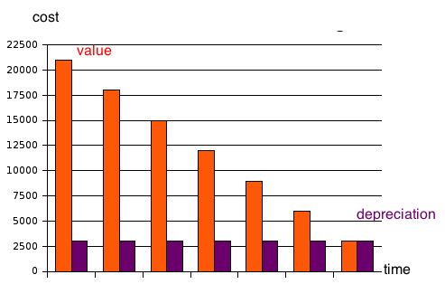

Figure – Linear depreciation of an asset over years

## Multiplicity

The *multitude* of any TCO-Object will be multiplied down the tree, for e.g.:

*Group* (multitude=2)

* + *Service* (multitude=3)
    - *Cost driver* (multitude=4)
      * *Fact cost* or *Personal Cost* (multitude=5)

This will generate the costs of the *last* object with:

🡪 multiplicity= 2*3*4*5 = 120

## Time duration

The TCO-Tool assumes a minimal time of interest on a **yearly base**. In reports the results are therefore accumulated year by year.

For a long time consideration the property “**Repeatable**” can be set to define that underlying costs must be re-invested after the TCO-Usage duration. Any Fact cost element can define its own TCO-usage and whether it is repeatable or not.

In the Fact cost dialog (s. 5.2.5) the lifetime of thing can be specified for the TCO- and Financial-algorithm separately:

* TCO-usage time: Lifetime a thing will be really used effectively until it must be replaced completely or not used at all any more.
* Depreciation time: time the value of a thing will be depreciated down to 0 by accountancy. However for the re-investment the TCO-usage time is relevant even for the Financial algorithm!

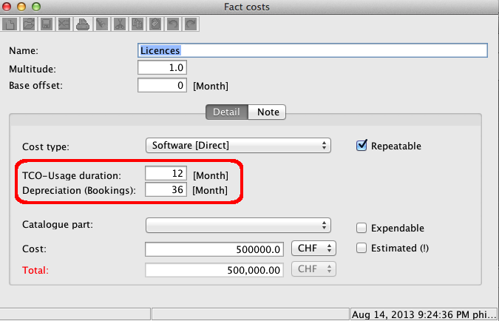

Figure – Duration for TCO or Financial aspects

For Personal cost the duration is set constantly to one year, by means a salary for resource should be entered for the whole year.

## Base offset

Every TCO-configuration is meant to start on a time-axis at “zero” (0).

Typically if you want to calculate the cost of a product or service you don’t know when your buyers will invest on it, therefore an investment date makes no sense in most cases.

Anyway sometimes a complex situation makes it necessary to schedule the costs a little later relatively to your starting time, therefore you can set the base-offset in months of such costs.

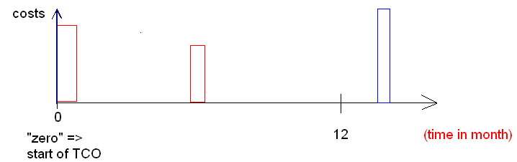

Figure - Base offset illustration

In the above example the red costs are made in the first year, the blue costs are to be invested later in the second year.

Therefore in a TCO-report the blue costs are irrelevant in the first year („TCO 1.year“).

## Dependency

S. chapter 5.2.3.1 and 7.1.2

Terminology/rules:

* “B depends on A to a certain percentage of x” can be expressed as:
  + “B --x%--> A”
* A is in this case totally independent, where B would not make sense without A.
* That is why the cost of B is in fact more expensive, at least x% of A additionally.

*Service/Group* costs may be shared among other *Service*s by defining a dependency from:

* a *Service* to another *Service*
* a *Service* to another *Group* (accumulates the costs of all elements nested/owned by the group)

Calculation sample for a *Dependency*:

Client-Service(own costs 100 CHF) ----50%--> Supplier-Service (own costs 500 CHF)

* + Client-service costs (incl. dependencies) = 100 CHF + 50% of 500 CHF = 350 CHF

Remark:

* Some reports consider these Dependencies (should be noted within the report explicitely), some do not!

## Risk-Calculation

TODO: based on estimated values etc

## Cost block

Any selected node in the model-tree can be calculated as a separate cost block. If a *Group* is selected it considers its contained sub-groups and *Services*.

# Generic Reports

Reports are based (triggered) either by:

* main Menu (s. chapter 5.1.1) on the whole configuration, by means over the complete *Base Information* tree
* By popup menu on a selected tree-node (for e.g. a Service)

The TCO-Tool offers a variety of HTML-reports which are displayed as internal frame in the reporting area. These can be printed or exported to *.HTML or *.CSV (comma separated files to be opened by a spreadsheet program for e.g.).

The “Reporting settings” described in chapter 5.3.2 will have an influence on all reports to be generated!

Remark:

* You can also implement your own reports by a Plugin[8]-mechanism.

## Configuration Reports

Reports based on all entered *Base Information.*

### Report (complete)

Shows all details of all *Base Information* like an “inventory” without considering any timelines (such as TCO or depreciation durations) or base offsets.

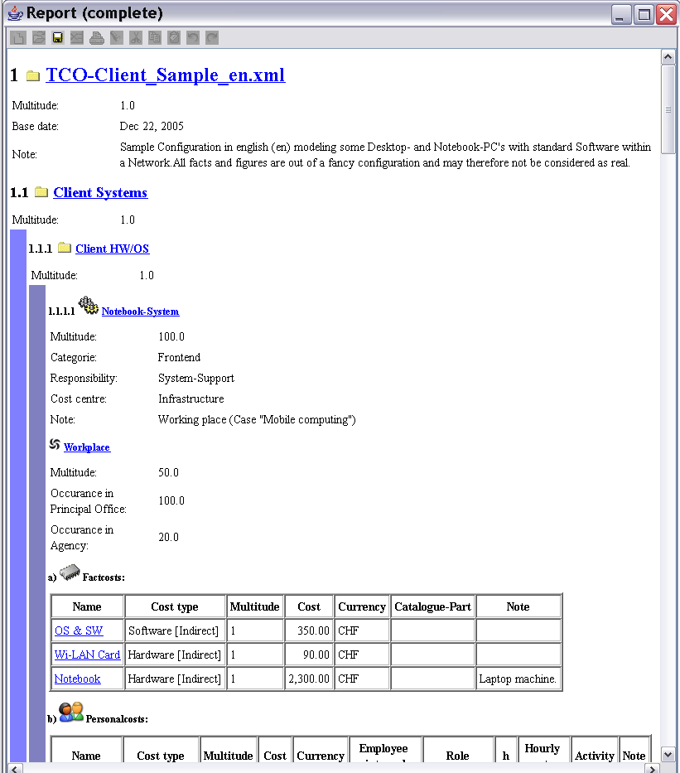

Figure 29 - Report (Complete)

### Dependency-Graph

Shows the cost dependencies (see chapter 5.2.3.1) between *Services* or *Groups*:

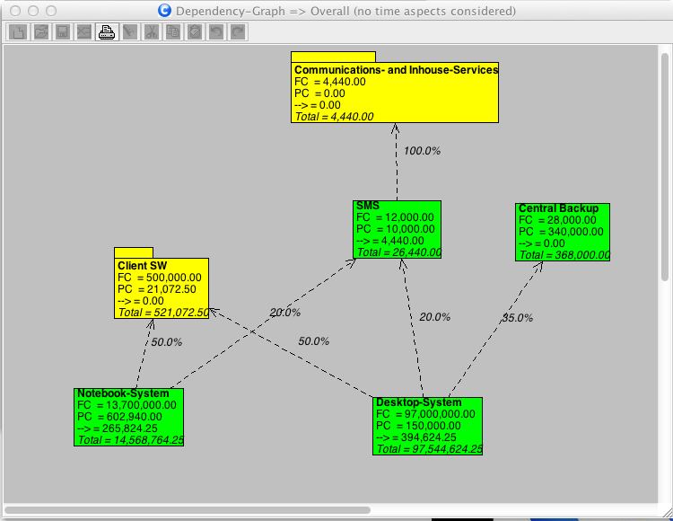

Figure 30 - Dependency Graph

## TCO-Reports

The following reports are related to a *TCO algorithm*.

The reporting period can be set to a desired time horizon by TCO max duration (s. 5.3.2).

### Cost block (overall)

Calculates TCO-costs over the complete configuration grouped for a subset of Business Codes.

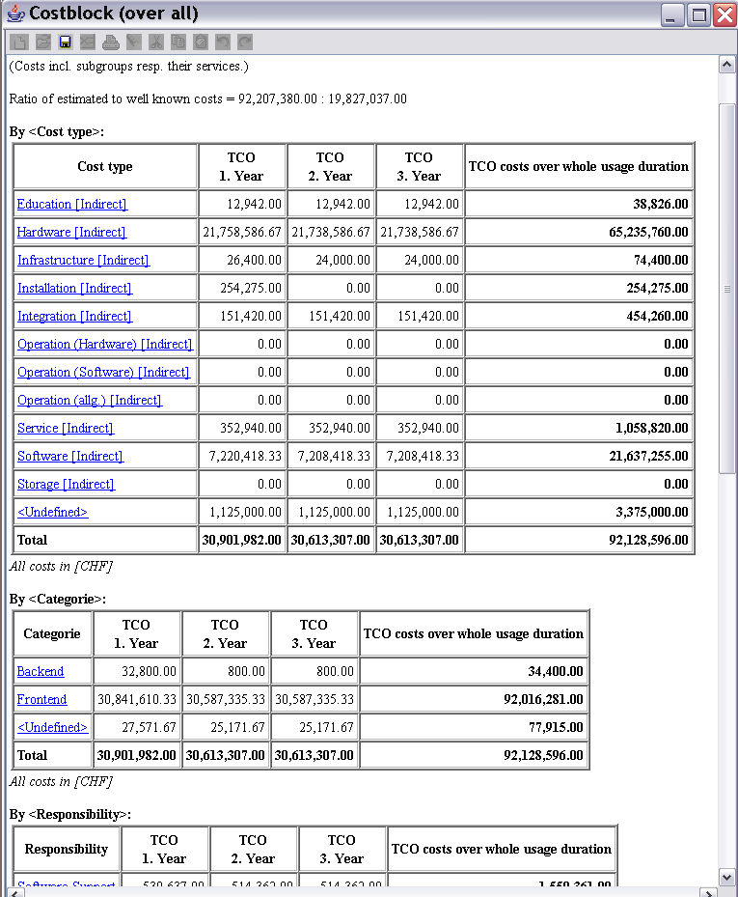

Figure 31 - Report: TCO-cost block (over all)

### Cost block (detailed)

Calculates TCO-costs for a selected *Service* or *Group*.

### Personal-/Fact costs (over all)

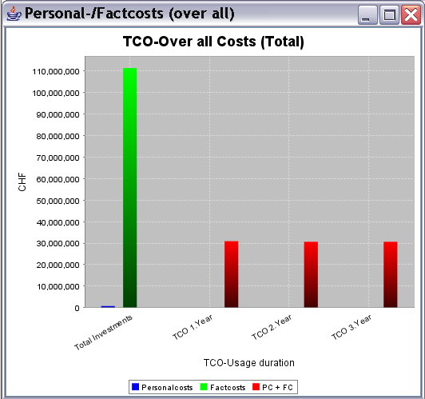

Figure 32 - Report: TCO Personal-/Fact cost (over all)

### Business objects (Codes)

Charts will be produced according to your chosen Code selection.

Important:

* Dependencies will be ignored for these reports, because accumulations are done by Code-assignments and therefore not by Services.

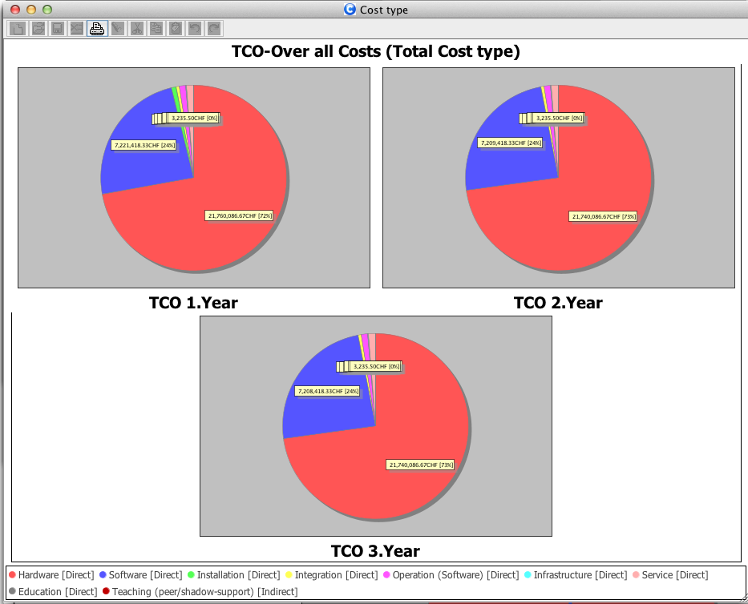

Figure - Sample pie chart

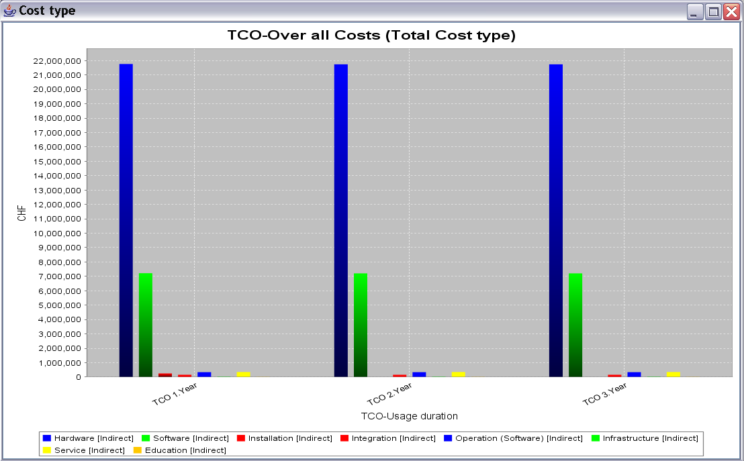

Figure - Sample bar chart

### Subordinate Business objects (codes)

Sometimes you want to know a specific combination for e.g. a certain cost-type by category.

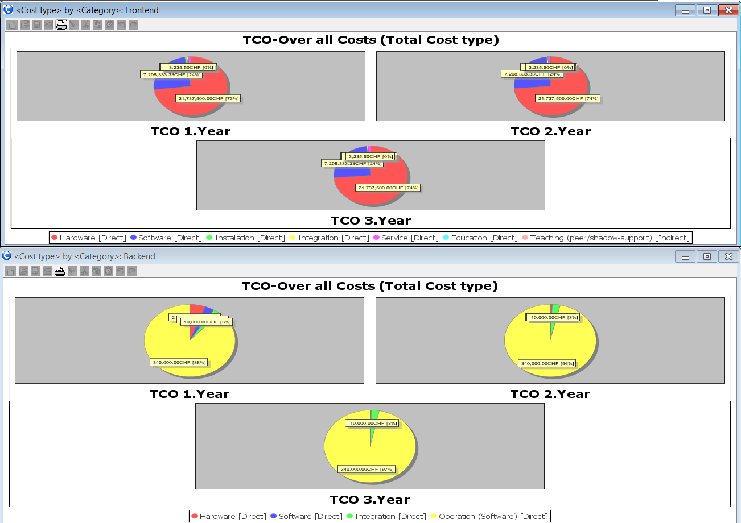

Figure - <Cost type> by a Frontend and Backend <Category>

### Direct/*indirect* costs

Show the sum of direct or indirect costs, based on Cost-type (see chapter 5.3.1.5):

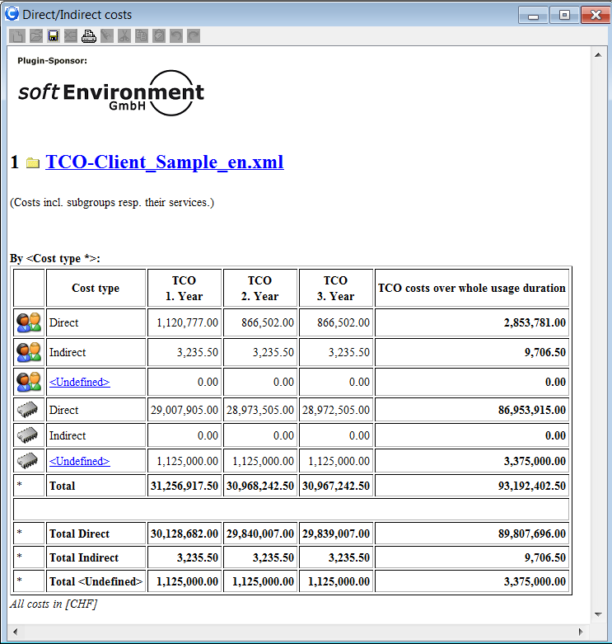

Figure - Direct/indirect costs report

### Dependency costs

Next to the “flat costs” some costs can be aggregated by given dependencies, therefore the real TCO costs might be higher than expected!

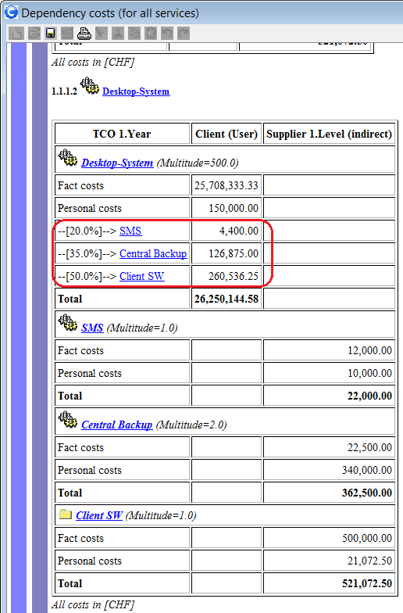

### Estimated costs

For any Fact/Personal cost you can determine whether you know the costs exactly or approximately only. This report gives an overview, which could also indicate a risk about your configuration (for e.g. if you have too many estimated costs):

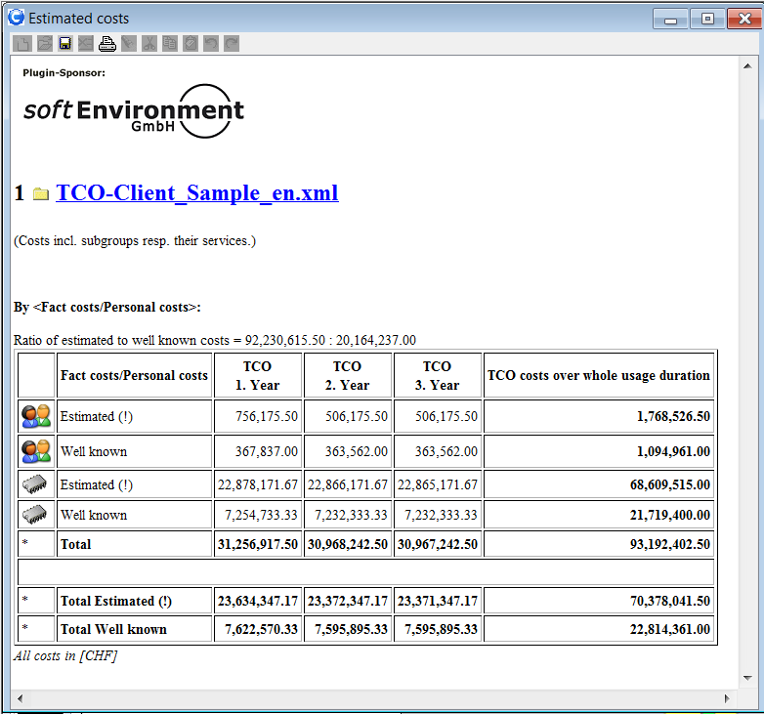

Figure - Estimated/well known costs report

### Price suggestion

A price per service is calculated according to its TCO dependency costs divided by the services multitude (do not expect too much here).

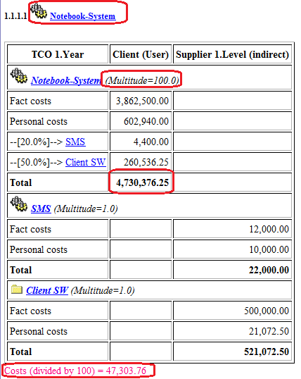

Figure – Price of a „single“ service instance

## Accounting/Financial Reports

The following reports are related to an *accounting view*.

### Personal costs

Shows booked efforts within configuration:

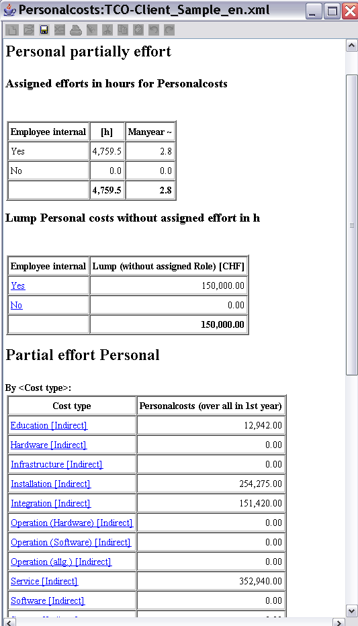

Figure 39 - Report: Personal costs

### Check personal effort

If you setup your Role’s (see chapter 5.3.1.6) especially their “Employment % available” values, this report will check, whether all given resources are allocated within your *Base Information*.

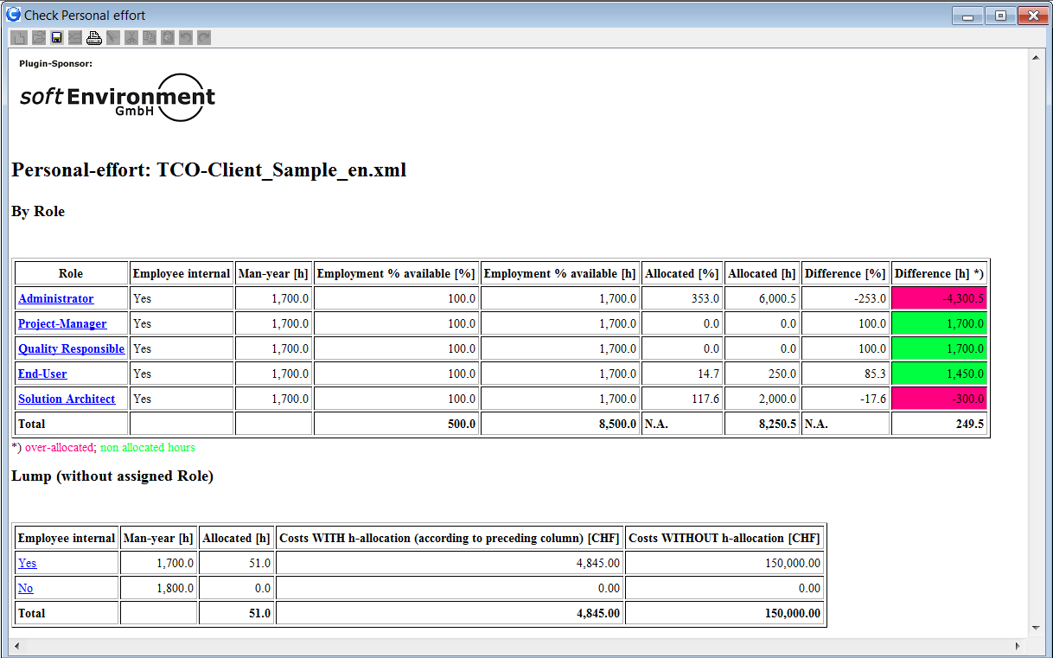

Figure 40 – Personal effort vice availability

### Investments

Shows all costs to be invested for a configuration:

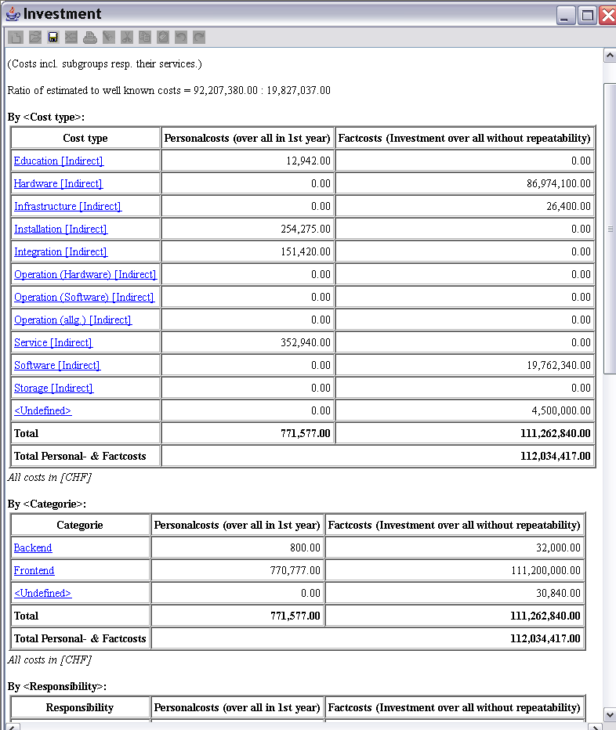

Figure 41 - Report: Investment

### Budget plan

This report will give you some Budget planning suggestion per year according to your *Base Information*.

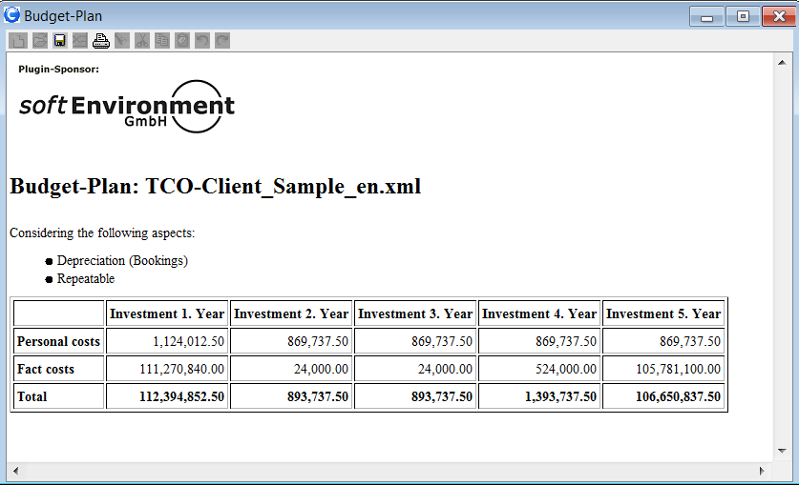

Figure 42 – Budget plan

### Depreciation[9]

Shows the depreciation costs of a configuration (booking accountancy).

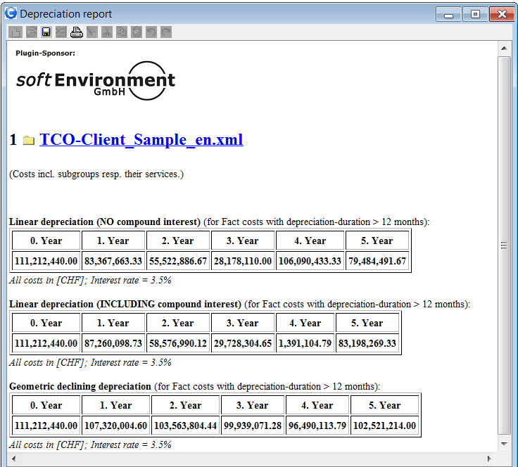

Figure - Report depreciation

# FAQ

Please use the forum at <http://sourceforge.net/projects/tcotool>

# Appendix

## TCO „Base Information“ Model-Elements

The specification of the UML2[10] class diagram for the TCO-Tool (these elements are also found in an XML configuration saved by the TCO-Tool):

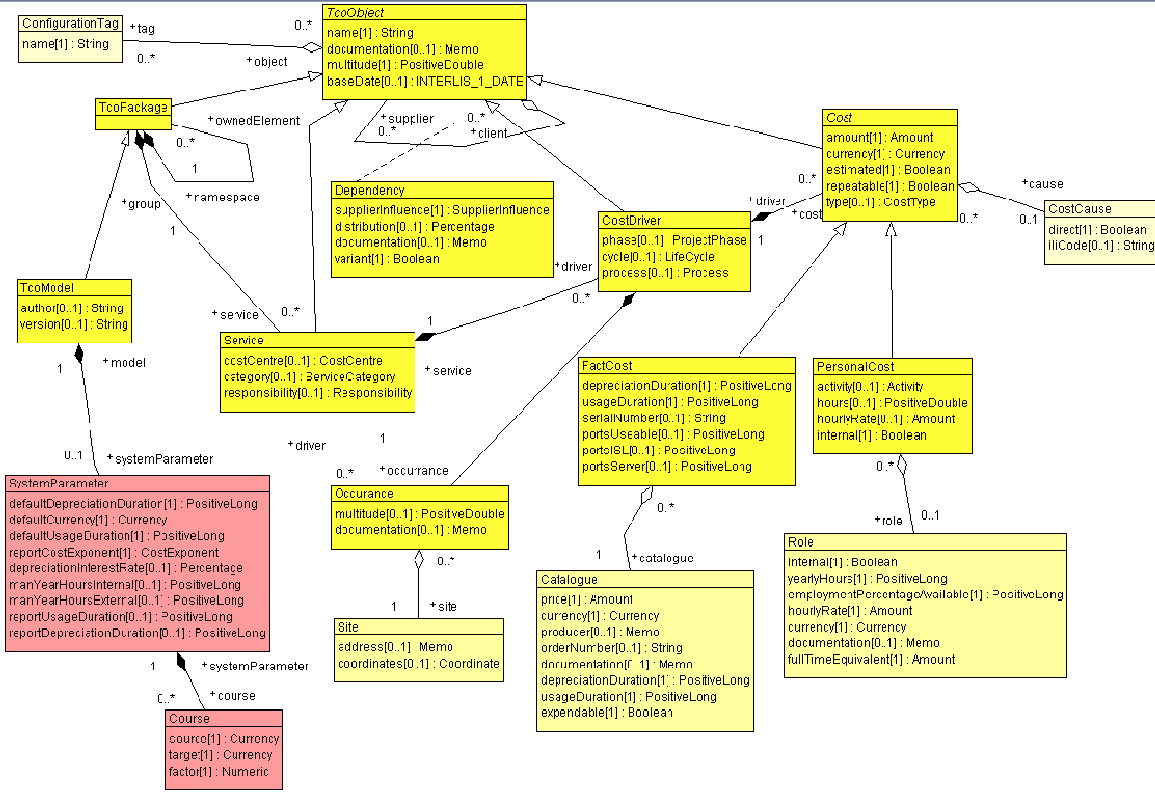

Figure – TCO-Tool Class Model

## Chart of Accounting [Gartner Group]

TODO: replace with en version

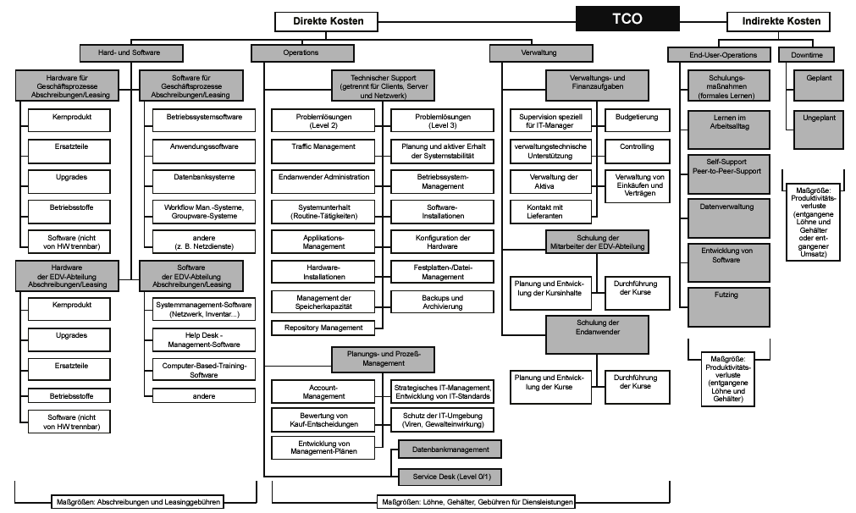

Figure – TCO Model v4.0 – Distributed computing Chart of Accounts

## Import Business Codes

Import codes from comma separated files (*.csv).

Expected separator: “;” (semicolon)

Headerline will be overread!

Each importable code has a unique Number property in case of re-import for synchronization or re-use of same codes in different TCO-configurations.

### Import “Cost-centre”

Format:

**Nr(Unique);Name;**

### Import “Cost-type”

Format:

**Nr(Unique);Name;Direct(Yes/No);**

1. See also <http://en.wikipedia.org/wiki/Total_cost_of_ownership>
2. Information and communication Technology
3. Comma Separated Values (*.csv)
4. Visible on the very top in the navigation tree.
5. de: Sachkosten
6. de: Verbrauchsmaterial
7. In Switzerland (IT) a regular 100% employee is about 1700, an external consultant is assumed about 1800 hours.
8. See „Developer-Manual“
9. Plugin sponsored by [www.*soft*Environment.ch](www.softEnvironment.ch)
10. Unified Modeling Language